**Problem Statement :**

ABC is a marketing firm and as part of contract with client, they share the real time advertising images.

They are looking for a solution to automate the process of tagging the brand name with the images.

Your task is to create the ML model capable to tagging image with the brand name by identifying the logo present in the image using the available dataset.

You are expected to deliver the solution for the above problem statement, considering the below guidelines and expectations:

1. Data Transformation steps and rationale

2. Machine Learning model - Neural Network.

3. Final model should be deployed on Cloud as an RESTful API to be consumed for evaluation

4. Free to choose between Flask and Django for developing RESTful webservice

5. Source code should be submitted to us.

Extra points - Creating a logo detection model for video processing.

Dataset - Please use flickr dataset available @ <http://image.ntua.gr/iva/datasets/flickr_logos/>

**Assignment Conclusions :**

The annotated data found for annotation is good enough to train models which can be used for recognizing the brand on the logo itself but it is having lesser performance on freestyle images where the logo is randomly placed across an image.

The Classical ML also performs quite good in comparison with Neural net but it has the least capability on freestyle images.

**Classic model Stats :**

**Annotated train performance : 99%**

**Annotated test performance : 95%**

**Neural Network Stats :**

**Annotated train performance : 92%**

**Annotated test performance : 95%**

**Webservice Operational Instructions:**

**This webservice is deployed using flask.**

**# Folder structure**

**---------------------------------------------------**

**Models are available in models folder**

**Sample image for test stored in samples folder**

**HTML page in template (styling from free templates of bootstrap)**

**Operational folder : Static**

**#Operation type**

**---------------------------------------------------------**

**UI driven webservice, can be added with additional features like JSON API response, database addition etc, based on requirement.**

**We take the image from user and the models behind will detect the logo present in the image.**

**# Webservice Running Instructions :**

**----------------------------------------------------------**

**1) Open git bash or cmd at the working directory containing the app.py script.**

**2) Execute [python app.py] command in the cmd.**

**3) Make sure you install requirements before running from requirements.txt file.**

**4) Requirements from text file can be installed by using following command pip install -r requirements.txt**

**5) The code runs and displays the IP on which the service is running**

**6) Browse the IP to find service,**

**7) Upload image to detect logo**

**8) Optional : if app.run(debug = True) is uncommented, it is in debug mode, to make it running normally**

**For any queries, can contact yuvaraj@outlook.in**

**- Yuvaraj**

**Webservice screenshots**

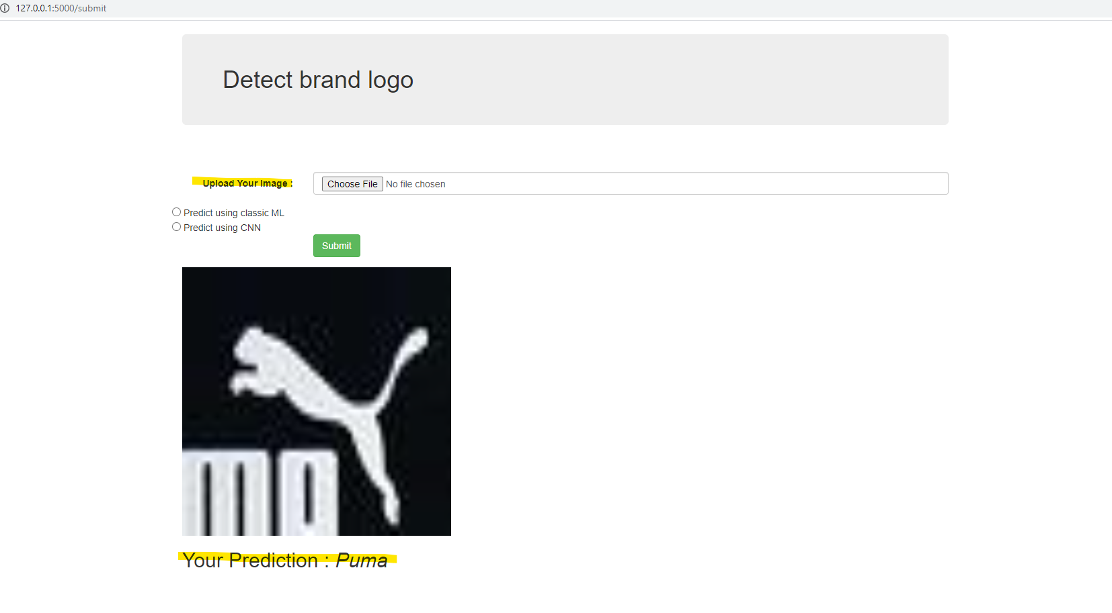

**Recommendations and further scope :**

There can be couple of strategies that can be done to improve prediction in freestyle as well.

1. The image can be split into different sub sections and the prediction can be done on each subsection and based on the proba score we can try predicting the values. Could also use a technique like slider functions to iterate through an image in smaller chunks to identify the target.

2. More data augmentation can be done to make the model learn all the logos well even in different strategic positions like flipped, rotated, cropped etc

3. More pictures can be annotated to increase the amount of train data which will also improve model performance.

4. Last but not the least, the model parameters can be tweaked in combination with above recommendations (Hyperparameter tuning), and different other algorithms can be used to check and improve the performance.